Guide to renewing MMAC membership
Go to website – BMAFS: BMAF Services Limited (GBR) (opentrack.run)
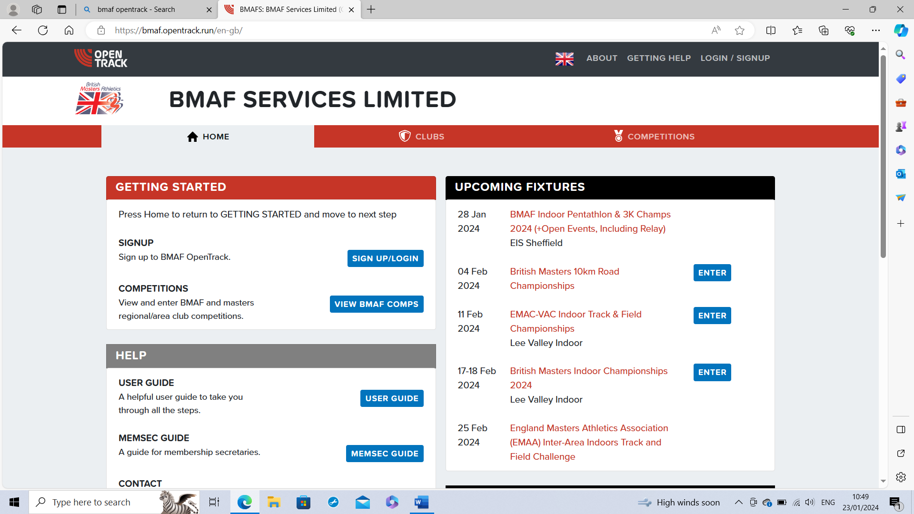
Log in with your email address and opentrack password
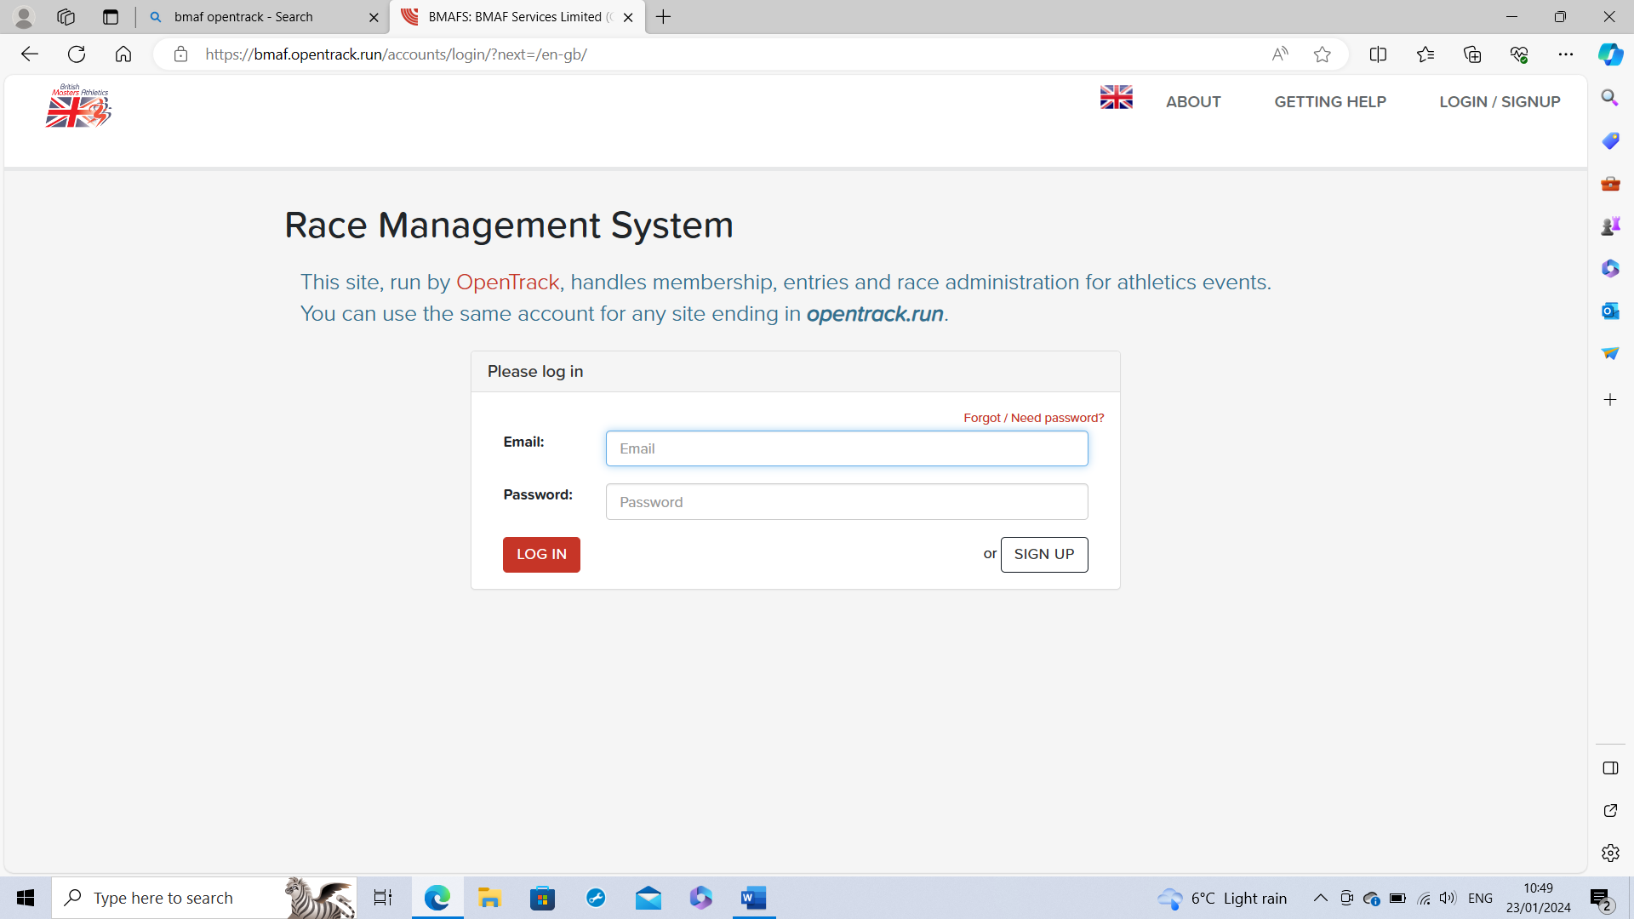
Click on Clubs
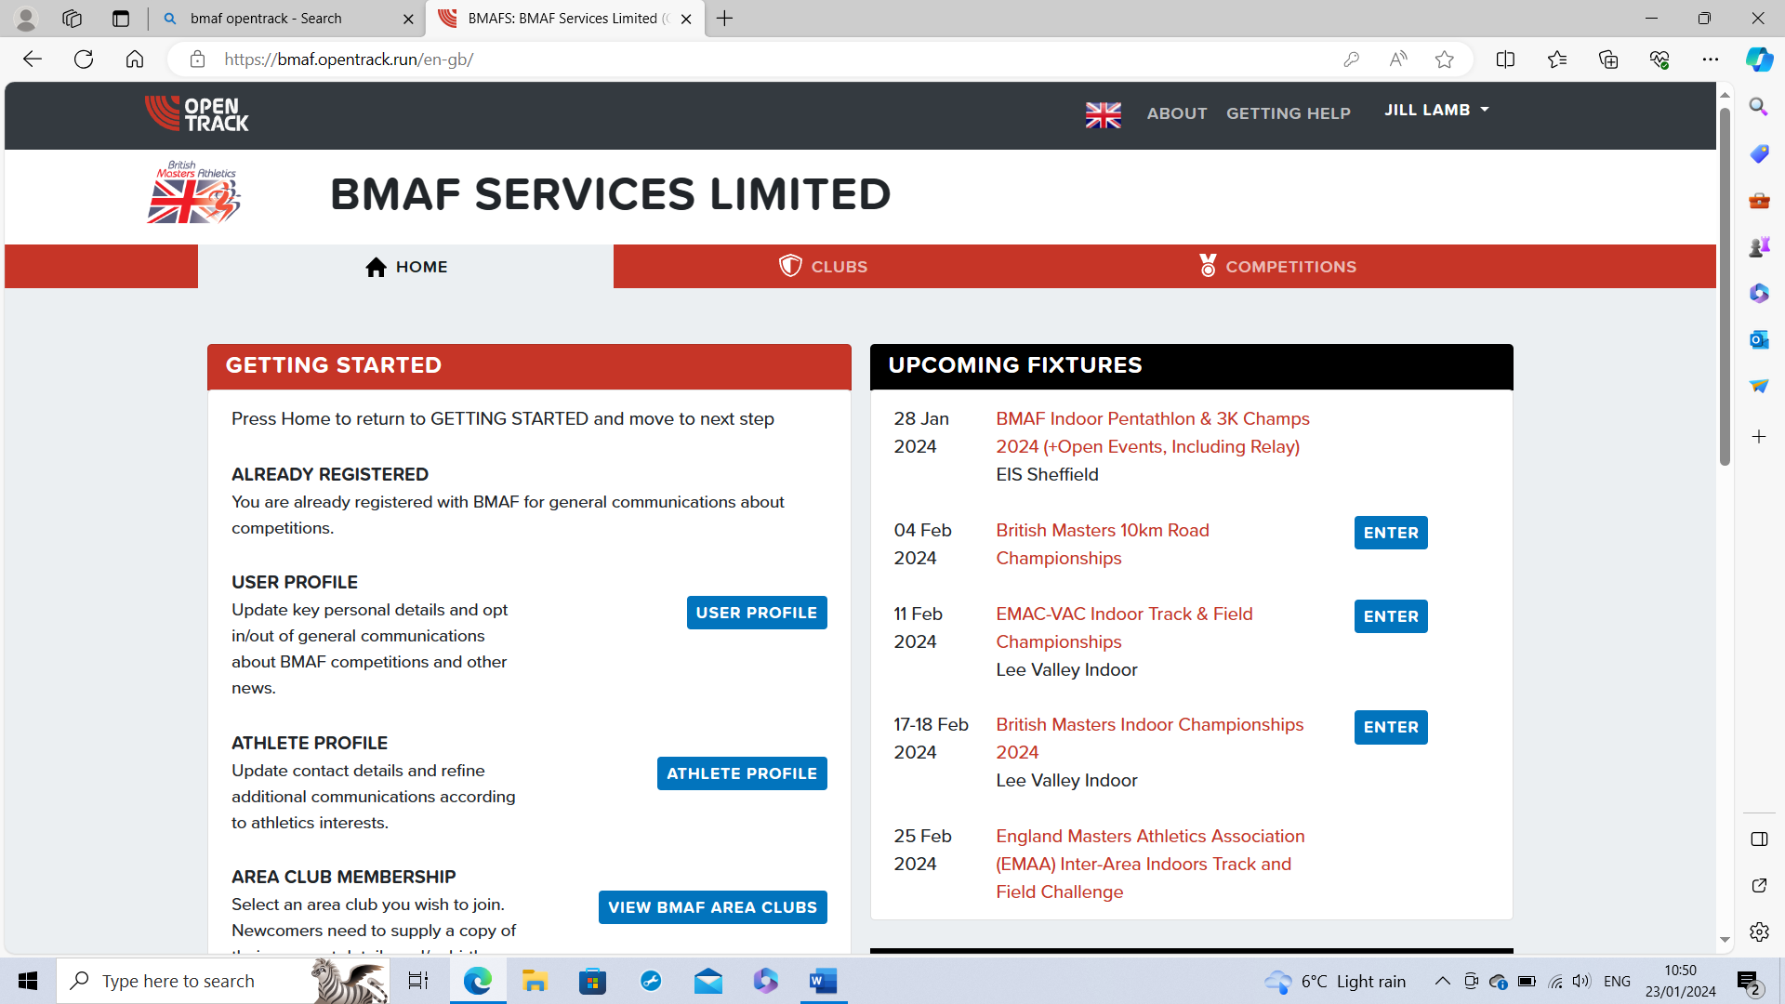
Click on MMAC renew button
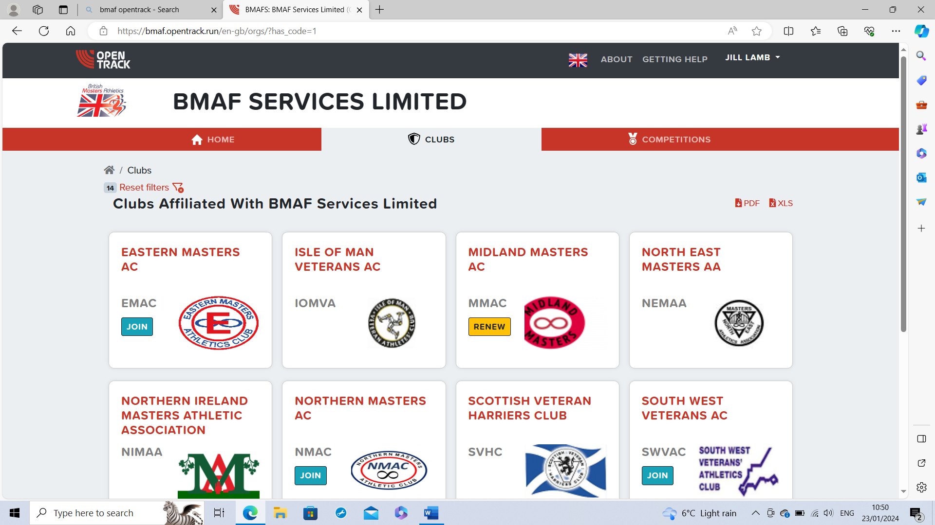
Choose membership type then click renew
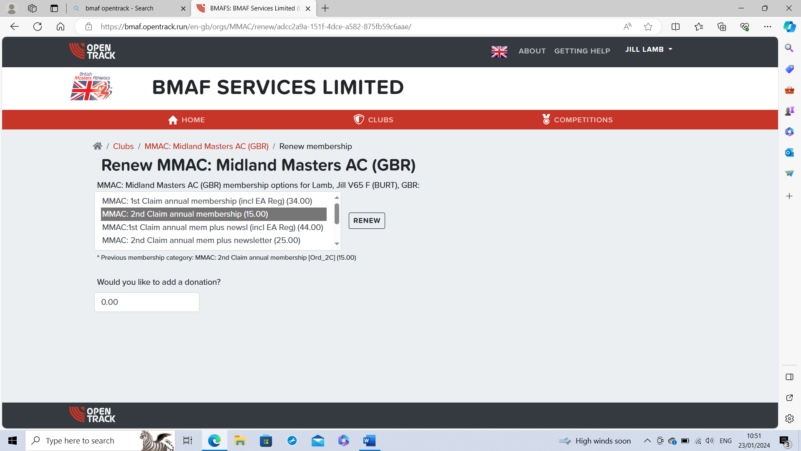
Enter card details and tick terms and conditions then press pay
Your name and membership No. will be here
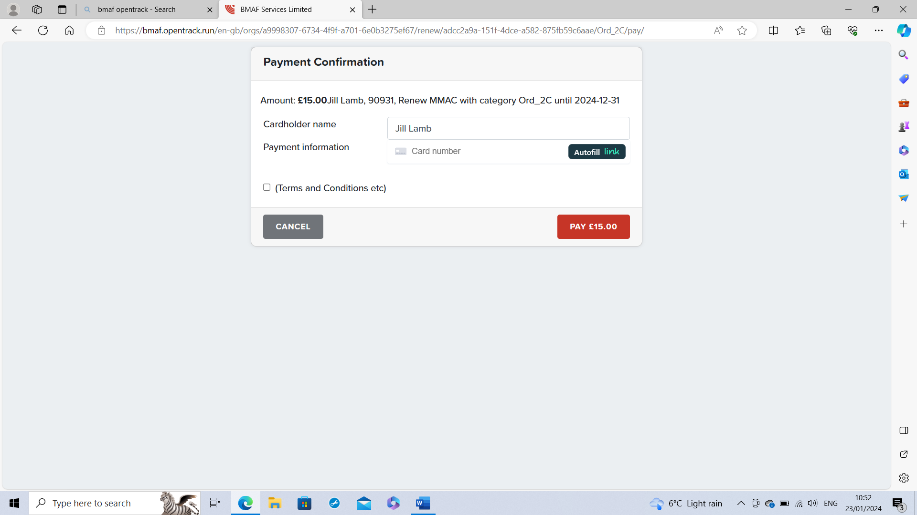
Confirmation screen will appear next
